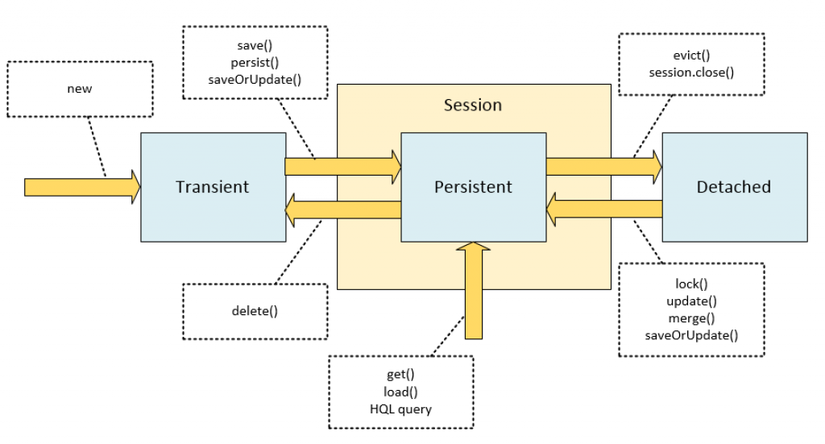

- What is Hibernate?
Hibernate is Object Relational Mapping (ORM) framework, which maps object to database table and columns.
What are the core interfaces of hibernate?
Configuration
Session Factory
Session
Query
Criteria
Transaction
What is session Factory?
Session Factory is a factory of sessions. It provides instance of session.
It holds data of secondary level cache that is not enabled by default.
What is a session?
It maintains connection between hibernate and database.
It provides methods to store, update, delete or fetch data from the database such as persist(),update(), delete(), load(), get() etc.
It is a factory of Query, Criteria and Transaction i.e. it provides factory methods to return these instances.
What is the difference between save and persist?
Persist is JPA specification where as save is hibernate specification.
Return type : persist return type is void where as save return type is seralizable object.
Outside of transaction: Persist method can be called outside transaction where as save not.
Identifier return : Persist method doesn't guarantee that identifier value is assigned to persistence instance immediately. Whereas save guarantees.
Difference between get and load?
Database hit: Get always hits the DB, while load() method may not always hit the database, it returns proxy object.
When object not found - get returns null if object not found in database, where as load returns Object Not Found Exception.
Proxy: Get method never returns a proxy, it either returns null or fully initialized Object, while load() method may return proxy, which is the object with ID but without initializing other properties, which is lazily initialized. If you are just using returned object for creating relationship and only need Id then load() is the way to go.
Performance: load slightly better performance.
When to use : If you don't know whether object exists or not , then go for get as it returns null , if you are sure object exists then go for load, as it returns Object Not Found Exception if object not found.
Example : Stock has many transactions , in order to update particular stock transactions we need stock id , there may be million of transactions, but using get to get stock id reduces performance as hits Db every time, so use load to get stock id which returns proxy object with stock id .
What are the states of object in hibernate?
Transient: The object is in transient state if it is just created but has no primary key (identifier) and not associated with session.
Persistent: The object is in persistent state if session is open, and you just saved the instance in the database or retrieved the instance from the database.
Detached: The object is in detached state if session is closed. After detached state, object comes to persistent state if you call lock() or update() method.
Difference between save and saveorUpdate?
save always inserts record into DB and returns identifier.
save or update, inserts record into DB if no record exists, else updates record in DB if already exists.
For example if you have saved object in one session and need to modify object in another session , then save method call leads to duplicate row insertion on identifier , in such use cases use save or update is more flexible.
Difference between update and merge?
Both update() and merge() methods seems similar because both of them are used to convert the object which is in detached state into persistence state.
When we call update() method, if the object already existed in cache update() method will throw exception where as merge() method copies the changes in to cache.
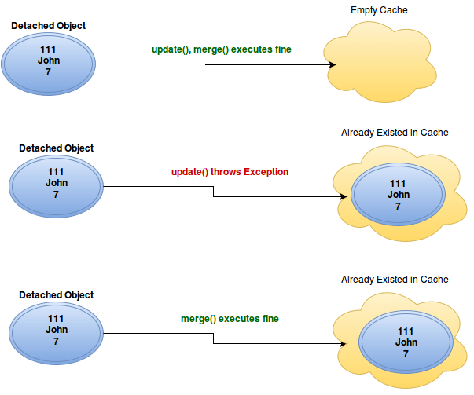
- primary keys
@Id
@GeneratedValue(Strategy=GenerationType.AUTO)
-- strategies- Auto - hibernate will decide
IDENTITY- Hibernate uses identity columns to generate id
SEQUENCE-
TABLE - Maintains separate table to generate Id
- Map value objects in hibernate?
Value objects - user has address and address has city street
Declare @Embeddable
Put Embedded for variable of address in user.
- How to save collection of objects
-- For example if user has list of address , then define @ElementCollection for address property which hibernate creates separate table with user_ addresses to store list of address by foreign of user id as user_id.
- How to change table name and joined column name of collection ?
Use @JoinTable(name = "ADDRESSES", join columns = @JoinColumn name="USER_ID" )
- How to configure one to one mapping?
For example if user has vehicle both are entities , we can use @OneToOne in user entity at field declaration of vehicle. If needed we can change join column name using @JoinColumn (name="" ).
Internal working : first hibernate creates and inserts values in user table and then it creates and inserts values in vehicle table and then it captures vehicle id and updates user table with the vehicle id which is join column.
- How to configure one to many in hibernate?
For example if user has many vehicles then use @OneToMany in user entity at vehicle field declaration.
-- Internal working: first hibernate creates and inserts values in user table and then it creates and inserts values in vehicle table and then it creates another table with vehicle and user primary key columns.
-- if we want to change join table and join column names then use
@JoinTable( name="" , @JoinColumns = @JoinColumn(name="USER_ID" ), @InverseJoinColumns(name ="VEHICLE_ID"))
- How to configure many to many in hibernate?
-- if users is rented vehicles then many users can have many vehicles ,
-- In user entity of field vehicles use @ManyTo Many and in vehicles entity of field users use @ManyToMany.
- Why we use mapped by in hibernate?
-- With the use of mapped by we will directly tell hibernate that one table is owns the relationship, therefore it is stored as column of that table , without that hibernate will create another table to store the releationship.
Example: << need to update java brains >>
- Why cascade in hibernate?
-- Cascade in hibernate defines if any operation like save update is happened at one entity, it decides whether need to call save update or delete on other entities which has relationship.
-- For example if user has 100 vehicles which is vehicle is another entity, we need to call save 100 times inorder to save in hibernate , it will be more when we have more vehicles , so therefore when we use @OneTomany(cascade=CascadeType.PERSIST) at vehicles list field of user entity and call persist with user. Which defines that whenever we use user object save vehicles object too.
- What is single table per hierarchy in hibernate?
-- Hibernate has default single table per hierarchy.
-- For example we have base class vehicle and two derived classes two-wheeler and four-wheeler entities, hibernate automatically creates single table with all the columns of base and derived classes and extra column Dtype which is discriminator for determining which class it is , and it will insert values in columns according to properties defined in entities of derived and base classes.
- How to configure discriminator name and type and values.
-- By default discriminator type is Dtype we can change in base class vehicle by defining @DiscriminatorColumn(name ="VEHICLE_TYPE",discriminator Type=DiscriminatorType.String(CHAR,INT))
-- By default discriminator value is class name like base class and derived classes , if we want to change value of derived class bike then use @DiscriminatorValue("BIKE") in two wheeler entity same for vehicle and four wheeler entity
- How to configure single table per class in hibernate?
-- simple just use @Inheritance ( strategy= INHERITANCETYPE.TABLE_PER_CLASS)
in base class entity ie vehicle. It will create duplicate columns.
- How to configure table per sub class in hibernate?
-- It will eliminate duplicate columns in sub classes which uses join by primary and foreign key relationship.
-- Simple just use @Inheritance ( strategy=INHERITANCETYPE.JOINED) in base class .
-- Use @PrimaryKeyJoinColumn(name="id") in derived classes and it is optional.
- CRUD operations in hibernate?
session.openSession();
session.beginTransaction();
session.getTransaction().commit();
session.close();
Get -
User user = session.get(entityclassname.class, )
Save-
session.save(user)
Delete-
session.delete(user)
Update-
session.update(user)
- What is query object in hibernate?
-- Query object in hibernate is used to create queries using session.createQuery which returns query object.
Example : QueryObject query = session.createQuery("from users where userid=5)
User users = (Users)query.list();
- How to use parameter binding in query object?
-- from where userid > ?;
query.setInteger(0,5);
-- 2 approach.from where userid > :userid
query.setInteger("userid",5);
- What is named query in hibernate?
-- Named queries are used to consolidate all queries at one place , so that it is easy to maintain.
@NamedQueries({
@NamedQuery(
name = "findStockByStockCode",
query = "from Stock s where s.stockCode = :stockCode"
)
})
@Entity
@Table(name = "stock", catalog = "mkyong")
public class Stock implements java.io.Serializable {
...
-- Calling named queries:
Query query = session.getNamedQuery("findStockByStockCode")
.setString("stockCode", "7277");
- What is native queries in hibernate?
-- Native queries are used to write database specific queries.
Query q = em.createNativeQuery("SELECT a.firstname, a.lastname FROM Author a WHERE a.id = ?");
q.setParameter(1, 1);
Object[] author = (Object[]) q.getSingleResult();
System.out.println("Author "
+ author[0]
+ " "
+ author[1]);
- What is criteria api?
-- Criteria api is used when we have many optional search criteria. It provides projections like maximim minimum and average and we can add restrictions eq lt like between isNull isNotNull
For example:
Criteria criteria = session.createCriteria(domainclass.class).addOrder(Order.asc("date");
criteria.add( Restrictions.eq("age",12));
To get records use criteria.list()
-- Criteria with projections
criteria.setProjection(Projections.sum("age"));
-- Criteria with projections list
criteria = this.getSession().createCriteria(Bulletin.class)
.setProjection(Projections.projectionList()
.add(Projections.property(bulletinIdAttr),"bulletinIdAttr")
.add(Projections.property(docNameAttr),"docNameAttr")
.add(Projections.property(docTypeCodeAttr),"docTypeCodeAttr")
);
criteria.addOrder(Order.desc(createdTimeAttr));
criteria.setResultTransformer(new AliasToBeanResultTransformer(Bulletin.class));
List bulletinList = criteria.list();

What is automatic dirty checking in hibernate?
The automatic dirty checking feature of hibernate, calls update statement automatically on the objects that are modified in a transaction.
What is the difference between first level cache and second level cache?
First Level Cache is associated with Session.Second Level Cache is associated with SessionFactory.
First Level Cache is enabled by default where as Second Level Cache is not enabled by default.
What is the difference between getCurrentSession() and openSession()?
Hibernate SessionFactory getCurrentSession() method returns the session bound to the context.
But for this to work, we need to configure it in hibernate configuration file like below.
<property name="hibernate.current_session_context_class">thread</property>
Since this session object belongs to the hibernate context, we don’t need to close it. Once the session factory is closed, this session object gets closed.
Hibernate Session objects are not thread safe, so we should not use it in multi-threaded environment.
We can use it in single threaded environment because it’s relatively faster than opening a new session.
-- Hibernate SessionFactory openSession() method always opens a new session. We should close this session object once we are done with all the database operations.
-- However, stateless session can be a good fit in certain situations.
For example where we are loading bulk data into database and we don’t want hibernate session to hold huge data in first-level cache memory.
What will happen if we don’t have no-args constructor in Entity bean?
-- Hibernate uses Reflection API to create instance of Entity beans, usually when you call get() or load() methods.
The method Class.newInstance() is used for this and it requires no-args constructor.
So if you won’t have no-args constructor in entity beans, hibernate will fail to instantiate it and you will get HibernateException.
What is difference between sorted collection and ordered collection, which one is better?
-- When we use Collection API sorting algorithms to sort a collection, it’s called sorted list.
For small collections, it’s not much of an overhead but for larger collections
it can lead to slow performance and OutOfMemory errors. Also the entity beans should implement Comparable or Comparator interface for it to work, read more at java object list sorting.
What are the collection types in Hibernate?
There are five collection types in hibernate used for one-to-many relationship mappings.
Bag
Set
List
Array
Map
Why we should not make Entity Class final?
Hibernate use proxy classes for lazy loading of data, only when it’s needed. This is done by extending the entity bean,
if the entity bean will be final then lazy loading will not be possible, hence low performance.
How to use application server JNDI DataSource with Hibernate framework?
-- For web applications, it’s always best to allow servlet container to manage the connection pool.
That’s why we define JNDI resource for DataSource and we can use it in the web application. It’s very easy to use in Hibernate,
all we need is to remove all the database specific properties and use below property to provide the JNDI DataSource name.
<property name="hibernate.connection.datasource">java:comp/env/jdbc/MyLocalDB</property>

